An E-Commerce Order Platform in Python: Proof-of-Concept Implementation

Mahesh Gaire
Basanta Ghorashainee
Sai Prasanth Chowdary Moparthi
Mayurkumar Bhavikkumar Patel
Xhon Pelushi
University of the Cumberlands
MSCS-532-M20: Algorithms and Data Structures
Course Project — Deliverable 2
Dr. Michael Solomon
July 17, 2026

Abstract
This report presents the proof-of-concept implementation of the e-commerce order platform designed in Deliverable 1. All six data structures — the separate-chaining hash table catalog, the search trie, the price binary search tree, the weighted co-purchase graph, the binary max-heap, and the circular-buffer order queue — are implemented from scratch in pure Python, each in its own module with documented complexity, and wired together by a facade class whose methods are business actions. A scripted demonstration walks one simulated shopping session through the full journey: prefix search, price filtering, order placement, fulfilment, recommendations, and dashboards, showing that an order processed by the queue immediately improves the recommendations the graph serves. A returns workflow completes the merchandising loop — accepted returns restock the catalog and drive a most-returned dashboard served by the same heap as the best-seller list — and a dependency-free browser portal renders the running system live, one panel per structure. Forty-two unit tests cover the core operations and their edge cases, including hash-table resizing, circular-buffer wraparound, duplicate prices, cumulative return caps, and atomic rejection of out-of-stock orders. The report documents the implementation challenges encountered — multi-word search, recursion limits, and failure atomicity — and sets out the optimization and scaling work planned for the next phase.

Introduction
Deliverable 1 argued that an e-commerce backend is best served by a composition of specialized structures rather than a single container. This phase tests that argument in code. The goal of the proof of concept is deliberately narrow: implement the core operations — insertion, deletion, search, and traversal — of each structure, prove them correct on edge cases, and demonstrate that they cooperate as one system. Full-scale performance work is deferred to Phase 3
Partial Implementation Overview
The code is organized as a package of six modules, one per structure, beneath a facade named ECommerceSystem whose public methods are the business actions of the store. The catalog hash table implements FNV-1a hashing, separate chaining, and load-factor-driven doubling, and is the single owner of product records; the resize can be disabled by a constructor flag, which Phase 3 will use to measure chain degradation. The trie indexes every word of each product name and answers prefix walks with an explicit-stack depth-first collection, with an optional result limit for autocomplete pagination. The price index is an iterative binary search tree in which duplicate prices share one node, following the classic treatment of ordered indexes (Bayer & McCreight, 1972); its range query prunes subtrees that cannot intersect the requested band. The recommendation graph keeps a weighted adjacency list and updates pairwise co-purchase counts as orders are fulfilled, the item-to-item formulation shown to scale independently of the user population (Sarwar et al., 2001). The max-heap implements sift-up, sift-down, O(n) bottom-up heapify (Cormen et al., 2022), and a non-destructive top-k that pops from a snapshot. The order queue is a circular buffer that doubles in place, unrolling its wrapped layout on growth. Beyond the shopping path, the facade exposes a returns action: process_return restocks through the catalog while capping cumulative returns at units actually sold, and most_returned ranks the returns counters with the same heap the best-seller dashboard uses, keeping demand and dissatisfaction as separate signals.
Every public method documents its asymptotic cost, and every module validates its inputs: negative prices and stocks, empty product names, empty orders, invalid ranges, and invalid k values all raise typed exceptions at the boundary rather than corrupting state deeper in the system.
Demonstration and Testing
The demonstration script seeds a fifteen-product catalog and replays a scripted customer session end to end (Figures 1 and 2). The seeding step reports each structure's internal statistics; the search steps show a single-prefix query and a two-word query answered by intersecting per-word matches; the price filter returns its results already sorted by the tree's in-order walk. Eight orders then flow through the queue, and the fulfilment loop's side effects are visible immediately afterward: the "customers also bought" panel for the Wireless Mouse ranks the Wireless Keyboard first because three of the eight orders contained both, and the best-seller and low-stock dashboards reflect the decremented stock counts. The final step demonstrates error handling: an order naming an unknown SKU is rejected at checkout, and a third order for a product with two remaining units fails cleanly once stock is exhausted.
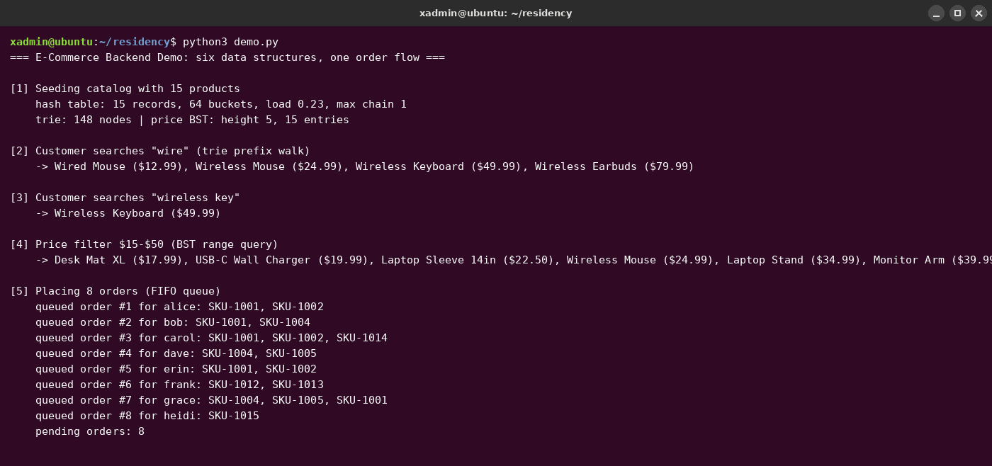
Figure 1. Demonstration, part 1: catalog seeding, trie searches, BST price filter, and order placement.
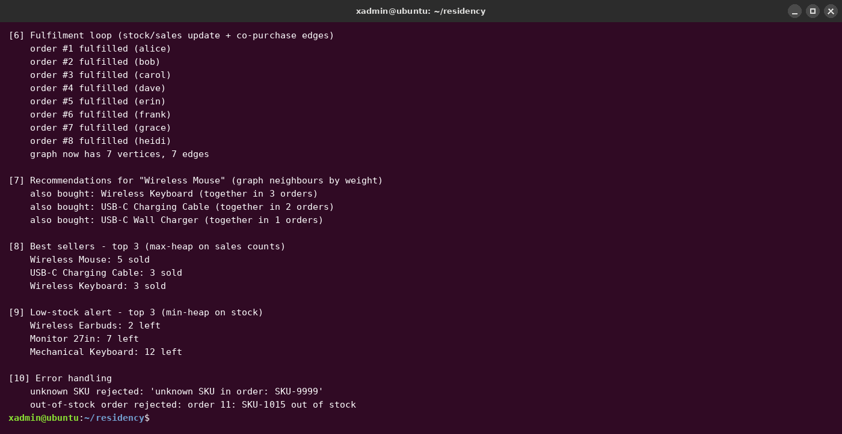
Figure 2. Demonstration, part 2: fulfilment feeding the co-purchase graph, dashboards, and error handling.
The same proof of concept also runs interactively. A browser portal (portal.py, built on the standard library's http.server so the project remains dependency-free) serves a single-page storefront in which every panel is answered by exactly one facade call and is color-coded to the structure behind it: live autocomplete on the trie, price filtering on the tree, the catalog table with per-product return buttons on the hash table, co-purchase panels on the graph, cart and fulfilment on the queue, and three heap dashboards — best sellers, low stock, and most returned (Figure 3). A metrics strip reports each structure's live diagnostics, and the page refetches the catalog, dashboards, and statistics after every mutation, so the browser view mirrors the backend's single-source-of-truth rule.
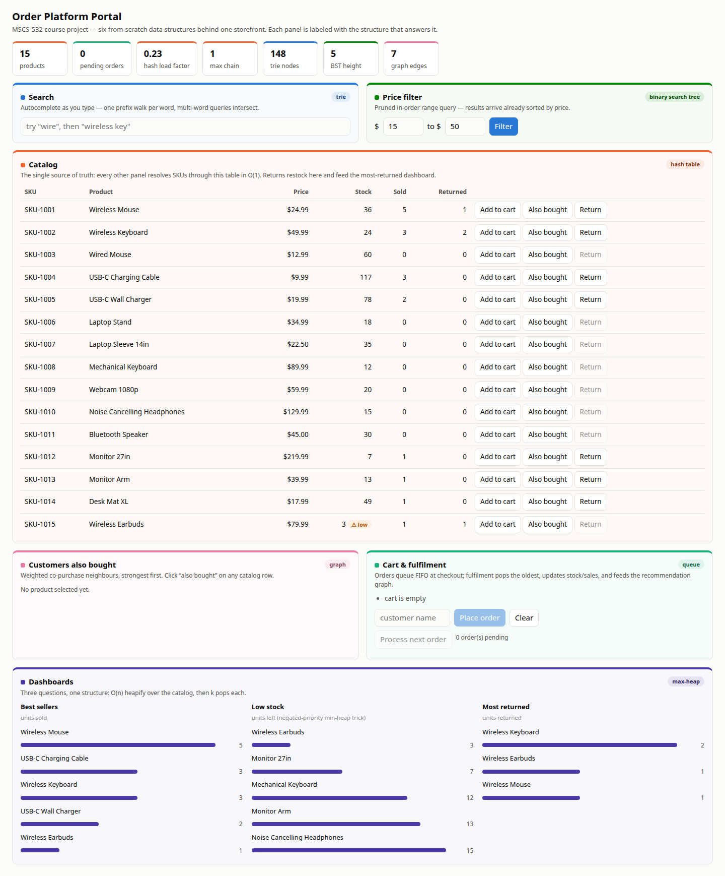
Figure 3. The browser portal: each color-coded panel is served by one data structure.
Correctness is enforced by forty-two unit tests (Figure 4) organized by structure, summarized in Table 1. Beyond the happy paths, the tests target the failure modes that matter for each design: the hash table is filled through multiple resizes and every record re-verified; the queue is grown from a two-slot buffer and drained across the wraparound boundary; the BST range query is checked against a brute-force scan on one thousand random prices; fulfilment of an under-stocked order is verified to fail atomically, leaving the other line items' stock untouched; and the returns path is verified to restock the catalog while rejecting returns of never-sold products and cumulative returns beyond units sold.
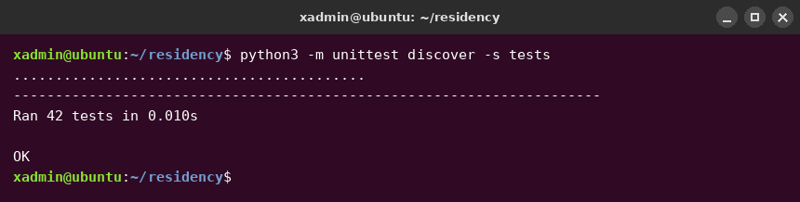
Figure 4. The unit-test suite: 42 tests passing.
Structure | Tests | Edge cases exercised
Hash table catalog | 7 | missing keys, in-place update, resize integrity, disabled resize
Search trie | 8 | case folding, second-word matches, limits, un-indexing, empty name
Price BST | 6 | inclusive bounds, duplicate prices, invalid range, brute-force cross-check
Co-purchase graph | 4 | self-loops, duplicate items, unknown SKUs, invalid k
Max-heap | 4 | priority order, heapify vs sorted, non-destructive top-k, empty
Order queue | 4 | FIFO across growth, wraparound reuse, empty
Integrated facade | 9 | duplicate SKUs, atomic out-of-stock failure, index cleanup on removal, cumulative return caps
Implementation Challenges and Solutions
Three challenges reshaped the code during this phase. First, the initial search implementation treated the whole query as one prefix, so "wireless key" matched nothing even though "wireless" and "key" each matched; the fix splits the query into words, walks the trie once per word, and intersects the SKU sets, preserving the first word's result order. Second, a recursive tree insertion risks Python's recursion limit precisely in the degenerate case Phase 3 must study, so both BST insertion and traversal were written iteratively with an explicit stack. Third, order fulfilment originally decremented stock while iterating line items, which could leave an order half-applied when a later item was out of stock; the final version validates every line item before committing any mutation, making failure atomic. The following excerpt shows the resulting fulfilment method, the single point where the queue, catalog, and graph interact.
def process_next_order(self):
order = self.orders.dequeue() # queue, O(1)
products = [self.catalog.get(s) for s in order.skus]
for product in products: # validate first
if product.stock < order.skus.count(product.sku):
order.status = "failed"
raise OutOfStockError(...)
for product in products: # then commit
product.stock -= 1
product.sales_count += 1
self.recommendations.record_order(order.skus) # feed the graph
order.status = "fulfilled"
return order
Next Steps
Phase 3 turns from correctness to performance on four fronts: generating synthetic catalogs of up to one hundred thousand products with a skewed order stream; benchmarking each structure against a naive baseline (fixed-capacity hashing, linear name scans, full sorts for top-k, and linear price scans); stress-testing the BST under monotone insertion, its known worst case; and measuring end-to-end order throughput and memory of the integrated system with time.perf_counter and tracemalloc. The results will drive targeted optimizations and quantify their effect against this deliverable's implementation as the baseline.
Conclusion
The proof of concept validates the Deliverable 1 design: six from-scratch structures, each correct on its edge cases, cooperate as one system in which commerce itself — the order stream — continuously improves the store's recommendations. The implementation is modular enough that Phase 3 can optimize individual structures without touching the facade's public interface.

References
Bayer, R., & McCreight, E. (1972). Organization and maintenance of large ordered indexes. Acta Informatica, 1(3), 173–189. https://doi.org/10.1007/BF00288683
Cormen, T. H., Leiserson, C. E., Rivest, R. L., & Stein, C. (2022). Introduction to algorithms (4th ed.). MIT Press.
Sarwar, B., Karypis, G., Konstan, J., & Riedl, J. (2001). Item-based collaborative filtering recommendation algorithms. Proceedings of the 10th International Conference on World Wide Web, 285–295. https://doi.org/10.1145/371920.372071

